SUSTAINABILITY REPORT
Yaliva Kamping
2025
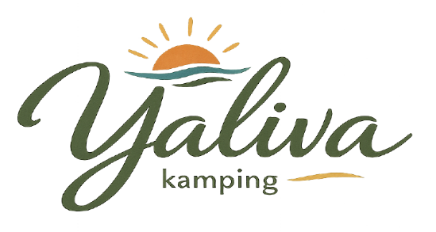
ŞAMLIOĞLU TURİZM OTELCİLİK ORGANİZASYON TİC. A.Ş.
TABLE OF CONTENTS
1. ABOUT THE REPORT 2
1.1. Sustainability Approach 2
1.2. Corporate Approach 3
1.3. Participatory Approach 3
1.4. Scope of the Report 4
2. ABOUT THE FACILITY 4
3. SUSTAINABILITY 5
3.1. Our Sustainability Team 8
3.2. Our Sustainability Efforts 8
3.3. Purchasing Management 10
3.4. Environmental Management 11
3.5. Waste Management 12
3.6. Energy Management 13
3.7. Water Management 13
3.8. Chemical Management 14
3.9. Geographical Awareness 14
3.10. Cooperation with Local Communities and Social Responsibility 15
3.11. Communication and Relations with Stakeholders 15
3.12. Protection of Biodiversity and Natural Areas 17
3.13. Protection and Support of Wildlife 18
3.14. Accessibility Opportunities for Everyone 19
3.15. Personnel and Working Life 19
4. CULTURAL AND HISTORICAL HERITAGE 20
4.1. Bodrum Castle 22
4.2. Bodrum Ancient Theatre 23
4.3. Myndos Ancient City 24
4.4. Myndos Gate 25
4.5. Mausoleum at Halicarnassus 26
4.6. Karakaya Village 27
4.7. Dibeklihan Culture and Art Village 28
4.8. Windmills 29
4.9. Ottoman Shipyard 30
4.10. Apostol Church 31
4.11. Zeki Müren Art Museum 32
Important Guidelines for Visiting Religious, Cultural, and Historical Sites and Museums 33
Important Considerations for Visits to Natural Areas 34
Wildlife Protection and Important Considerations During Nature Trips 34
https://tr.wikiloc.com/rotalari/bisiklet/turkiye/mugla/bodruM 34
5. OUR SAVING MEASURES 34
6. OUR GOALS 35

- ABOUT THE REPORT
  - Sustainability Approach
Sustainability refers to the responsible use of environmental values and natural resources in a way that prevents waste, while considering the rights and benefits of both present and future generations. The aim is to ensure balanced development across social, economic, ecological, and cultural dimensions, while enabling today’s progress without compromising the ability of future generations to meet their own needs.
Sustainable Tourism is defined by the United Nations World Tourism Organization as “tourism that takes full account of its current and future economic, social and environmental impacts, addressing the needs of visitors, the industry, the environment and host communities.”
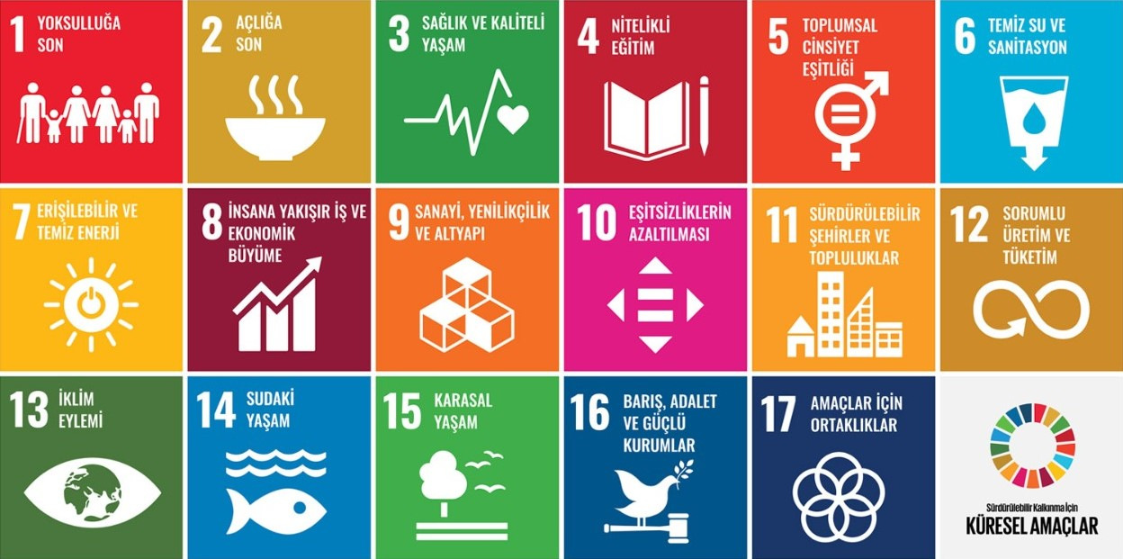
Görsel 1.1.1: Global Goals for Sustainable Development

We pay close attention to energy conservation and strive to use our energy as efficiently as possible. We are committed to protecting our energy and energy resources.

We pay close attention to water conservation and strive to use water efficiently in order to reduce our overall water consumption as much as possible.
We manage our waste in a controlled manner from the moment it is generated at its source. By following the Zero Waste System in our waste reduction practices, we always act with environmental responsibility and awareness.

  - Corporate Approach
Our facility continues its efforts toward a better world with full awareness of its responsibilities in all dimensions of sustainable development. Without compromising our high service standards and our principle of 100% guest satisfaction, our primary goals include controlling consumption, protecting natural resources, and minimizing negative impacts on the economy.
In the areas where we are involved throughout the lifecycle process;
We embrace the protection of social and cultural values and support non-governmental organizations.

In our procurement of products and services, we prioritize local businesses and support their growth and development.
We contribute to sustainable development by preferring institutions and organizations that protect the rights of producers and workers and promote fairer trade conditions.

The ultimate outcome we aim to achieve, as part of our responsibility to future generations, is to recognize the changes that will shape the future and to take action toward a more sustainable way of living. To achieve this;
We prefer and promote cycling as an environmentally friendly mode of transportation that reduces carbon emissions to zero. We also encourage the use of public transportation such as buses.
We continuously adapt to up-to-date regulations in order to ensure accessibility and usability for people of all ages, abilities, and circumstances.
.

  - Participatory Approach
Our sustainability efforts are shaped through the contributions of our management, employees, guests, suppliers, and business partners. By sharing this process transparently, we aim to raise awareness, embrace common goals, and achieve success together.

  - Scope of the Report
We aim to fulfill all of the Sustainable Development Goals established to address social, cultural, and ecological issues under the 17 main goals targeted by United Nations member states to achieve by the end of 2030, within the scope of our Sustainable Tourism activities.
Our vision is to preserve our brand value by creating more employment opportunities in hospitality through reliable, respectful, and environmentally conscious practices, while building a livable environment for future generations with a strong sense of responsibility.
Our mission is to be your home where you can experience the region in its most natural, pure, and authentic form.
Our obligations and principles are to operate in accordance with all applicable laws, regulations, and professional business standards, while upholding the values shaped by our corporate culture.
In all of our activities, our core principles are to ensure continuous improvement and sustainability through a people- and environment-oriented approach and sustainable resource management.
With our understanding of sustainable tourism, we aim to continuously improve by transforming our management approach, staff, guest accommodation practices, perspectives, sensitivities, resources, and all hospitality operations. In order to leave livable resources for future generations and to recognize the right of other living beings to exist on our planet, we commit to improving ourselves within the framework of legal regulations. From now on, we plan to share our activities within this scope transparently with all our stakeholders. We would also like to announce that we will share performance data regarding our development through the reports we prepare.
This sustainability report includes data from the previous one-year period as well as targets for the upcoming year. While preparing this report, our practices and achievements from previous periods were also taken into consideration.

- ABOUT THE FACILITY
The features of our facility are as follows:
Accommodation: Bed & Breakfast
Service Languages: Turkish, English
Nearest Airport: Milas–Bodrum Airport (BJV)
Distance to the Airport: 50 km
Distance to the City Center: 18 km
Distance to the Sea: 3 km
Hotel Buildings: 30 bungalows
Year of Construction: 2026
Last Renovation Date: 2026
Number of Rooms and Beds: 30 rooms and 60 beds
Elevator: None
Reception Service: 24 hours
Parking Facilities: Free Outdoor Parking
Check-in / Check-out Times: 14:00 – 11:00
Pool Services:
- Swimming Pool: 2 pools, 98 m² each (Maximum Depth: 150 cm)
- Children’s Pool: 14 m² (Maximum Depth: 45 cm)
- Pool Hours: 08:00 – 18:00
- Pool Facilities: Changing Cabins, WC, Shower, Sunbeds & Umbrellas, Towels
Other Services and Facilities:
- Laundry Service: Extra (Paid Service)
You may use the following communication channels for your feedback and inquiries.
- Coordinates: Latitude 37.108859, Longitude 27.311475
- Address: Dirmil Neighborhood, 6124 Street No: 10, Bodrum/MUĞLA
- Phone Number: +90 (549) 313 54 54
- E-mail: yalivakamping@gmail.com
- Website: yalivakamping.com
- Facebook: facebook.com/yalivakamping
- Instagram: @bodrumyalivakamping

- SUSTAINABILITY
In order to ensure the efficient use of natural resources with a sense of environmental responsibility, our goals are to minimize all types of waste generated through resource consumption, separate waste at its source, and dispose of hazardous materials without harming the environment; to comply with relevant laws and regulations while continuously improving our practices; to contribute to raising environmental awareness among our employees, guests, tour operators, suppliers, and society; to make our policy a way of life; to ensure the continuity of our practices across all areas of life; and to remain transparent and open to public review.
We aim to provide regular training for our employees, continuously improve their working conditions, identify potential hazards and risks in advance, and prevent possible occupational accidents and work-related illnesses.
In compliance with legal requirements and our own standards, our occupational health and safety policy is to protect human health and human rights within a spirit of teamwork, provide a safe and healthy working environment, raise awareness among all employees through training, and instill the principle of not endangering their own health and safety, the safety of other employees, or that of our guests. By continuously reviewing our risk analyses, we strive to improve our culture of prevention.
We aim to prevent discrimination based on race, gender, disability, or similar factors, to work toward preventing the exploitation of vulnerable groups, and to increase both the quantity and quality of local employment generated by tourism, including improvements in wages and service quality.
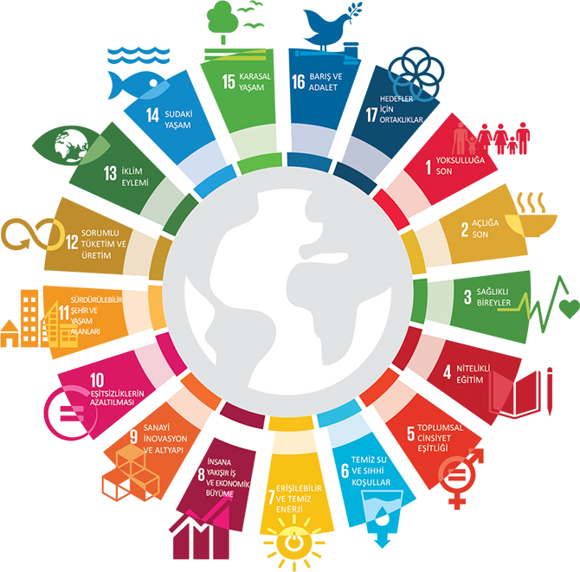
Görsel 3.1: Main Sustainability Topics
Our Objectives:
- To protect nature and wildlife,
- To preserve our cultural heritage,
- To use resources more efficiently and responsibly,
- To contribute to society through social responsibility initiatives,
- To strengthen the sense of belonging among our employees,
- To grow and improve together through continuous learning, while protecting our most valuable assets — our children and women — with a fair and equal approach,
- To maintain stronger communication with the local community and contribute to the development opportunities of the region in which we operate.

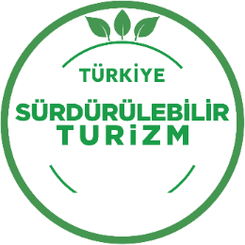
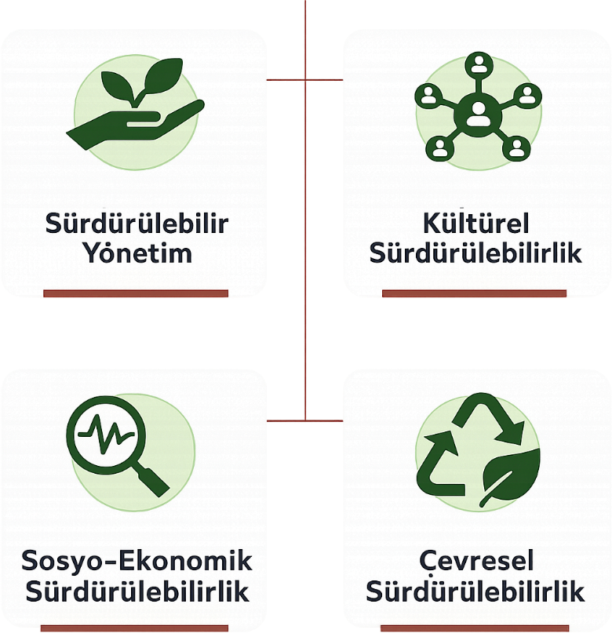
A Sustainability Risk Analysis covering the areas shown in the figure has been conducted, potential risks have been identified, and existing measures have been defined. Necessary actions are planned in order to ensure the sustainability and continuity of the system.
We continue our activities with the awareness that compliance with all relevant legal regulations is mandatory. All regulations with which we are required to comply have been identified in the legal compliance tracking list. We receive external support in areas outside our expertise. For example, our Occupational Safety Specialist provides support regarding the Occupational Health and Safety Law and related regulations, while our Environmental Consultant provides support regarding Environmental Legislation and related regulations.
Through our memberships in relevant non-governmental organizations and associations, we closely follow developments in the hospitality sector and manage legislative changes collaboratively through these channels as well.
All required legal permits and documents are available. Time-limited documents are regularly monitored and renewed when necessary.
In order to measure our performance throughout our sustainability journey, indicators have been identified, targets have been established, and progress is continuously monitored.

  - Our Sustainability Team
Main Responsibilities of the Team:
- Establishing the Sustainability Management System,
- Preparing the Sustainability Report,
- Setting sustainability goals and targets,
- Preparing relevant policies, procedures, and instructions,
- Reviewing sustainability policies every six months,
- Ensuring the implementation and dissemination of sustainability principles throughout the hotel,
- Establishing systems and raising awareness for receiving stakeholder feedback,
- Developing projects related to the environment, cultural heritage, wildlife, biodiversity, and social issues.
Frequency of Meetings: Monthly (General) / Once every 6 months (System Review / Management Review)
Meeting Agenda: Determined prior to each meeting

  - Our Sustainability Efforts
Our facility is committed to providing accessible tourism services for everyone within its capabilities and clearly and accurately informing its guests and stakeholders about its level of accessibility through its website.
Our aim is to contribute to cultural heritage and minimize damage to cultural heritage.
Our purchasing policy is based on local sourcing, environmental awareness, fair trade, and efficient procurement. We monitor our suppliers’ sustainability-related processes.
Our goal is to maximize guest satisfaction by identifying our guests’ expectations and needs in advance.
Our aim is to provide social and economic benefits to the local community and minimize negative impacts on the public.
Our facility provides accurate information to all audiences in its promotional activities and always uses authentic visual materials. Through its website, social media accounts, and other printed and written promotional channels and marketing communications, our facility maintains a transparent and realistic approach regarding its products and services.
In the regions where we operate, we take all necessary measures to increase local employment, protect and enrich natural life, and share with the public all activities carried out to protect our environment.
Through this sustainability report published on behalf of the facility, the sustainability performance and impacts of our operations are presented to the attention of all stakeholders. We continue our activities as a tourism investment company that prioritizes guest satisfaction.
- We protect the environment, prevent pollution, and place importance on reducing our negative environmental impacts.
- We strive to use water, energy, and all natural resources efficiently and share this awareness with our employees, guests, and suppliers.
- By preferring materials labeled as “recyclable” and “environmentally friendly” in our operations, we contribute to the protection of nature. We also strive to create opportunities for reuse.
- We measure our environmental management performance, monitor this data through targets, and work to improve our performance.
- In order to fulfill both our responsibilities toward nature and our legal obligations, we follow national and international standards, laws, and regulations.
- We store waste properly according to its characteristics in designated areas and deliver it to licensed/authorized companies within legal storage periods while maintaining records accordingly.
- We support local and regional development and employment.
- We respect the labor rights of our employees and monitor compliance within the framework of legal regulations.
- We support the elimination of child labor.
- We provide regular training for our employees and offer opportunities for development and advancement.
- We provide our employees with a healthy and safe working environment and offer various channels through which they can communicate their requests, suggestions, and complaints.
- We inform our guests and employees about the natural and cultural heritage of the local region.
- We evaluate all feedback from our guests and improve our processes in line with the data obtained.
- We evaluate and analyze the quality and qualifications of products and services together with users during procurement processes. We act fairly, honestly, and impartially in supplier selection.
- We respect human rights and reject all forms of discrimination based on language, religion, race, gender, or similar factors. We oppose any form of commercial, sexual, or other exploitation or harassment directed toward specially protected and vulnerable groups. We support measures against domestic violence and child abuse. One room is available for disadvantaged individuals. Pets are not accepted.
At the end of each year, we plan to evaluate our sustainability performance and share it online with all our stakeholders.
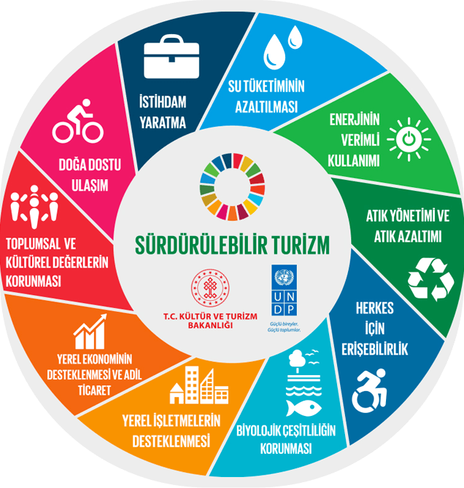
Görsel 3.2.1: Sustainability Goals
  - Purchasing Management
Our facility establishes its supply chain by basing our purchasing processes on a sustainable and environmentally friendly perspective. This policy includes various subtopics:
Legal Compliance: In all our purchasing processes, we cooperate with reliable suppliers who comply fully with local and national legal regulations and uphold ethical values.
Minimization of Environmental Impact: We prioritize purchasing from nearby regions in order to minimize CO2 emissions generated by suppliers’ delivery vehicles. Through this approach, we reduce environmental impacts while also supporting the local economy.
Energy Efficiency and Recyclable Products: In the products we purchase, we prefer energy-efficient, certified, repairable products with recycled content. In this way, we encourage environmentally friendly products.
Certified and Environmentally Friendly Products: Among our suppliers, we prioritize products with certified recycled content. By giving preference to environmentally friendly suppliers, we remain committed to sustainability principles.
Sustainable Construction and Furniture: When selecting construction and furniture materials, we prefer recycled or renewed products sourced from sustainable resources, locally produced, and environmentally certified materials.
Promotion of Sustainable Transportation: We encourage the purchase of vehicles with minimized environmental impact. In this way, we aim to contribute to sustainable transportation.
Endangered Species and Natural Resources: We make efforts not to use endangered species within our supply chain, to avoid hunting activities, and to support sustainable resources.
Local Partnerships: In order to support increased employment, we prefer to collaborate with local suppliers while establishing our supply chain.
In line with our business’s sustainability mission, we aim to fulfill our environmental and social responsibilities.

  - Environmental Management
As an environmentally conscious and eco-friendly facility;
  - Waste Management
We manage our waste in accordance with the Waste Management Hierarchy (WastePyramid).
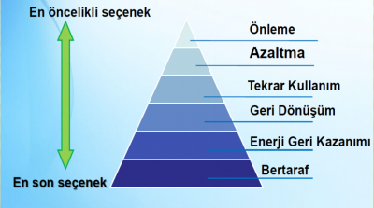
Görsel 3.4.1: Waste Pyramid
Waste reduction methods have been identified and are managed according to waste types. Detailed information is provided in the Waste Management Plan.
Waste is separated at the point where it is generated. Waste that cannot be separated at its source is sorted in Hazardous and Non-Hazardous Temporary Waste Storage Areas to ensure it is sent for recycling. The responsibilities for the collection and disposal of waste are defined in the Waste Management Plan.

  - Energy Management
For energy conservation, the opinion of the energy manager is taken into consideration during the purchasing process of electricity-consuming equipment.
- LED technology is used in all lighting systems throughout the hotel (100%).
- Exterior lighting systems are equipped with daylight-sensitive timers.
- Energy-saving insulated comfort glass is used throughout the facility.
- Energy-efficient, inverter, and new-generation gas (R32) split air conditioners are available.
- The settings of climate control devices in the rooms are managed under the supervision of the technical service team.
- Awareness is increased through sustainability and energy efficiency training programs and informational posters.
Electricity consumption is calculated and managed on a per-guest basis. The monitoring of targets and deviations is regularly followed by management.

  - Water Management
The issue of water is increasingly making itself felt on a global scale in social, economic, and environmental areas. According to the Risk Report prepared for the World Economic Forum, water scarcity is among the three most significant risks in the world. This situation will affect not only water-stressed basins but also many production processes. With the increasing volume of international trade, water is now considered a global resource rather than a local one. Therefore, the sustainability of freshwater resources is of critical importance not only from social and environmental perspectives, but also for the sustainability of the economy. In this context, when the Water Risk Map is examined, it is seen that dam occupancy rates are decreasing due to climate change. The efficient use of water is also an important focus for us.
For this purpose, we take various measures within our hotel:
- Without compromising health, hygiene, and guest satisfaction, we use water-saving equipment to reduce overall water consumption (aerators in kitchen and room sinks).
- We inform guests about water consumption and train our employees on this matter.
- In addition to low-flow faucets and showerheads, we prevent unnecessary water use through sensor-operated or timed faucets. We reduce flush water consumption through low-volume reservoirs. Water consumption in room reservoirs has been reduced by 50%. Flush systems have dual-stage mechanisms.
- We train our staff to detect and prevent water leaks from room toilets and expect our guests to report such leaks to us.
- We irrigate our nature-friendly garden using drip and sprinkler systems. In addition, water consumption is minimized through automation within the irrigation system.
- Towel and linen changes in rooms are carried out according to guest requests, and guests are informed about this practice. If there is no request from the guest, changes are made every two days.
In sinks, while normally 8 liters of water flow per minute, this amount is reduced to 3.5 liters with the use of a regulated water flow controller.
In shower faucets, while normally 18 liters of water flow per minute, this amount is reduced to 9 liters with the use of a regulated water flow controller.
In showerheads, while normally 12 liters of water flow per minute, water consumption is reduced to 8.5 liters with the use of a regulated water flow controller.
Water consumption is calculated per room/per guest. Monitoring of targets is carried out by management.

  - Chemical Management
An inventory has been created for the chemicals used. Attention is paid to ensuring that supplied chemicals are biodegradable. Relevant documents are obtained from supplier companies. The MSDS documents of chemicals are reviewed and kept in areas accessible to employees. Mixtures are carefully prepared to ensure optimum chemical consumption. Mixing ratios are included in the inventory. Special dosing mechanisms are available on bottles. Employees are provided with training on chemical usage.
Guests are informed so that they may request room cleaning and textile changes when needed.
Necessary precautions are taken in chemical storage areas. Chemical Storage Matrices and Chemical Usage Instructions are available.
.

  - Geographical Awareness
As a destination hosting the region’s unique natural and cultural heritage, it holds special importance in geographical awareness efforts. The peninsula’s distinctive topography, Mediterranean climate, endemic vegetation, and coastal ecosystems present elements that must be carefully addressed within sustainable tourism practices. In this context, it is critically important for all stakeholders operating locally to act with sensitivity toward the environmental carrying capacity of the region.
The lifestyle of the local community, architectural texture, and traditional production practices are among the fundamental elements shaping the geographical identity of the region. Therefore, preserving and sustaining region-specific values is a priority in sustainability practices. In particular, local production and agro-tourism activities carried out in rural neighborhoods both support economic development and increase geographical awareness.
Increasing construction pressure and tourism intensity create the need for strategic planning in terms of protecting natural resources. Accordingly, region-specific solutions should be developed regarding water resource management, protection of coastlines, biodiversity monitoring, and waste management. Geographical awareness is not only about recognizing the natural environment, but also about adopting a sense of responsibility that ensures its sustainable management. We continue our activities with full awareness and understanding of all these factors.

  - Cooperation with Local Communities and Social Responsibility
Society / Local Community:
- A local community representative has been appointed. The Stakeholder Feedback Form has been designed to manage feedback received from the community.
- It is important for us that the community is not negatively affected by our activities. We take this issue into consideration while conducting Environmental Impact Analysis.
- For us, the community also includes neighboring establishments.
- Our goal is to procure supplies from the local community and employ local residents. These are monitored through performance indicators.
- In order to support the local community, informational materials have been prepared for guests, and shopping areas/markets, etc. are promoted and recommended.

  - Communication and Relations with Stakeholders
Our Stakeholders:
- Our Board of Directors
- Our Employees
- Our Guests / Customers
- Society
- Our Suppliers / Contractors
- Other Facilities
- Official Institutions, Municipalities and Village Headmen, Non-Governmental Organizations

Our Guests:
Our guests are the reason for our existence. One of our primary values is to monitor all guest complaints received from every source, resolve complaints, and turn them into opportunities for improvement by informing our guests throughout the process. Through surveys in our rooms and the Guest Satisfaction Survey Form, we collect and manage feedback from our guests. By implementing corrective and preventive actions, we aim to increase and maintain customer satisfaction. Within this scope, we have updated our surveys and feedback forms in order to inform our guests about our sustainability efforts and enable them to provide feedback in this area.
In addition, we monitor guest feedback received through agencies.
We also record, evaluate, and respond to feedback received from our employees through our Employee Feedback Forms.

Our Suppliers & Contractors:
- Our goal of integration with and support for the community is achieved by working with local suppliers. Products used in our open buffet and à la carte restaurant are sourced from local farmers whenever possible, and guests are informed about this practice.
- Our local supplier ratio is monitored as a performance indicator. Of our total 23 suppliers, 18 are sourced locally. Currently, this rate is 78%.
- Our Supplier Selection and Evaluation Criteria have been restructured by taking sustainability principles into consideration. Our aim is also to support the development of our suppliers. All suppliers have been informed about our sustainability journey.
- Products and services procured are evaluated within this scope, and relevant documents related to these areas are requested (for example: Eco, FSC, ASC, MSC, ISO certificates, etc.).

Relations with Official Institutions / NGOs:
- Relations with official institutions are maintained within the scope of declarations and inspections, and no issues are experienced regarding the continuity of the facility’s certifications and documents.
- Relations with NGOs are developed by the Facility Management. Within this scope, some of the associations with which we maintain relations or hold memberships are listed below. .
No | Faaliyetin Konusu | Yapılan Çalışmalar
1 | NGO Membership | We are a member of BODER. (Bodrum Touristic Hoteliers, Operators and Investors Association)
2 | To protect the soil and prevent erosion and desertification. | We make sapling donations to TEMA Foundation.
3 | Protection of natural, historical, and cultural assets | We make financial donations to ÇEKÜL Foundation.
4 | Support for education | We support education by making donations to public schools in our region.
5 | Local Community Engagement and Support | We support local and social engagement by making donations to KIZILAY and YüCİTA

  - Protection of Biodiversity and Natural Areas
The region hosts a rich biodiversity as an important part of the regional biogeography. Endemic plant species, coastal and marine ecosystems, wetlands, and maquis flora are among the main elements that increase the ecological value of the region. This natural richness is a strategic asset that must be protected not only for environmental sustainability but also for cultural and economic sustainability.
Increasing tourism activities and urbanization pressure bring the risk of habitat fragmentation and a decrease in species diversity. Therefore, it is of great importance to develop conservation strategies based on cooperation among local authorities, tourism enterprises, and non-governmental organizations. In particular, habitat monitoring studies carried out in less developed areas such as Gölköy, Mazı, and Karaova, as well as nature conservation projects conducted with the participation of local communities, are among the positive examples.
Activities carried out within the scope of biodiversity conservation include the mapping of seagrass beds, monitoring of caretta caretta nesting areas, supporting bee populations, and preserving local seeds. These practices both ensure the continuity of ecosystem services and strengthen the connection between local communities and nature. The protection of natural areas becomes possible not only through physical boundaries but also through social awareness and participation.
We closely follow and support all these activities carried out throughout the destination.

  - Protection and Support of Wildlife
Due to being located at the intersection of terrestrial and marine ecosystems, the region possesses a rich diversity of wildlife. Sea turtles (Caretta caretta), Mediterranean monk seals (Monachus monachus), and various bird species observed especially along the coastline are among the main living groups that increase the ecological value of the region. The protection of these species is not only an environmental responsibility but also a fundamental component of the sustainable tourism vision.
Among the activities carried out to support wildlife are the protection of nesting areas, reduction of light pollution, control of plastic waste threatening marine life, and ensuring the continuity of natural wildlife corridors. In particular, monitoring and rehabilitation activities conducted in sensitive areas such as Küdür Peninsula, Gölköy Lagoon, and the surroundings of Mazı are carried out in cooperation with local NGOs and academic institutions.
The development of wildlife-friendly living practices by local communities and businesses is critically important for the success of conservation efforts. In this context, it is recommended that tourism facilities operating in the region give special consideration to wildlife elements within environmental impact assessments, ensure that construction planning does not harm natural habitats, and expand awareness-raising training programs. Protecting wildlife is a strategic investment not only for the continuity of existing species but also for the sustainability of ecosystem services. We support and share such investments for the protection of wildlife.
By monitoring endemic and native plant species as well as local animal species living in the region, we aim to develop activities that may contribute to biodiversity.
Some of the local endemic species are as follows:
✔ Bodrum Mandalinası (Citrus Reticulata)
✔ Frenk İnciri (Opuntia Ficus-İndica)
✔ Zeytin (Olea Europaea)
✔ Karabaş Otu (Lavandula Stoechas)
✔ Deniz Börülcesi (Salicornia Europaea)
✔ Keçiboynuzu (Harnup) Ağacı (Ceratonia Siliqua)
✔ Kenger Otu (Gundelia Tournefortii)
✔ Isırgan Otu (Urtica Spp.)
✔ Yılan Dili (Arum Maculatum)
✔ Tilkişen, Yabani Kuşkonmaz (Asparagus Acutifolius)
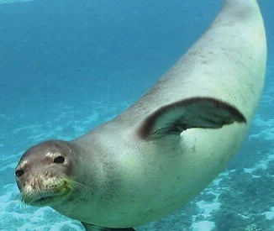
✔ Çeti (Latincesi Sarcopoteriumspinosum)
✔ Akdeniz Foku (Monachus Monachus)
✔ Dil Balığı (Solea Solea)
✔ Barbun Balığı (Mullus Barbatus)

  - Accessibility Opportunities for Everyone
The region is a dynamic tourism destination where individuals from different age groups, physical ability levels, and socioeconomic backgrounds come together. This diversity makes the development of accessibility opportunities for everyone not only an ethical responsibility but also a fundamental component of sustainable development. Accessibility should be considered not only as physical infrastructure, but also as the equal right to access information, services, and experiences.
In recent years, efforts to make public areas, coastal walking paths, cultural facilities, and accommodation establishments compliant with accessibility standards have accelerated. In particular, ramps designed for wheelchair users, elderly individuals, and visually or hearing-impaired guests, as well as audio guidance systems and accessible menus, are among the concrete examples of an inclusive tourism approach. These practices improve the quality of life for both local communities and visitors.
The cooperation of local authorities, the private sector, and non-governmental organizations plays a critical role in improving accessibility opportunities in the region. Accessibility audits, staff training, and improvement processes based on user feedback aim to make inclusivity an institutional culture. In addition, steps are being taken in digital accessibility, ensuring that websites, mobile applications, and digital content comply with accessibility criteria. Accessibility for everyone is a cornerstone of a future vision aligned with the principles of social justice and equality.
We also continue to make improvements in our facility in terms of accessibility.
  - Personnel and Working Life
We attach great importance to ensuring that all our employees work in a healthy, happy, and safe working environment. We make efforts to employ staff from the local community. In this way, through the multiplier effect of the economy, we contribute to revitalizing the local economy through the employment we provide.
As an establishment providing international-standard services to guests from different countries and nationalities, discrimination based on nationality, race, language, religion, etc. is against both our hospitality values and our working principles.
Our primary principle is to treat all employees fairly regardless of sexual orientation, age, gender, ethnic origin, religious belief, or disability status.
Within this scope;
✔ We adopt an open, equal, transparent, and fair management approach that includes employee participation.
✔ We provide equal, standard, and safe working conditions.
✔ We prioritize listening to and resolving problems.
✔ We implement a fair working and remuneration policy that complies with legal regulations and established standards.
✔ We listen to our employees and implement a communication model in which ideas can be freely expressed and dialogue is encouraged (through our complaint channels).
✔ We ensure that our employees feel safe and we protect their personal information.
✔ We prioritize the right of employees to get to know their workplace, improve themselves, and receive training.
- CULTURAL AND HISTORICAL HERITAGE
Bodrum, which carries a sense of romance within everyone, has been one of the most popular settlements of the Mediterranean from the age of myths to the present day. The town, first named “Halicarnassus,” later came to be known as “Bodrum” and was considered one of the leading cities of the region called “Caria.” According to the works of the famous historian Herodotus, the city was founded by the Lelegians in 2000 BC.
Among Bodrum’s most famous landmarks, the Windmills and Bodrum Castle are symbolic structures of the town and among the most visited attractions.
Museum Card: With a Museum Card, you can visit many ancient sites and museums in the region, especially the Bodrum Museum of Underwater Archaeology, without paying any additional fees.
If you wish, you can visit the Culture Portal created by the Republic of Türkiye Ministry of Culture and Tourism through the link below to access information about places to visit, traditional cuisine, and tourism activities.
https://www.kulturportali.gov.tr/turkiye/mugla/genelbilgiler

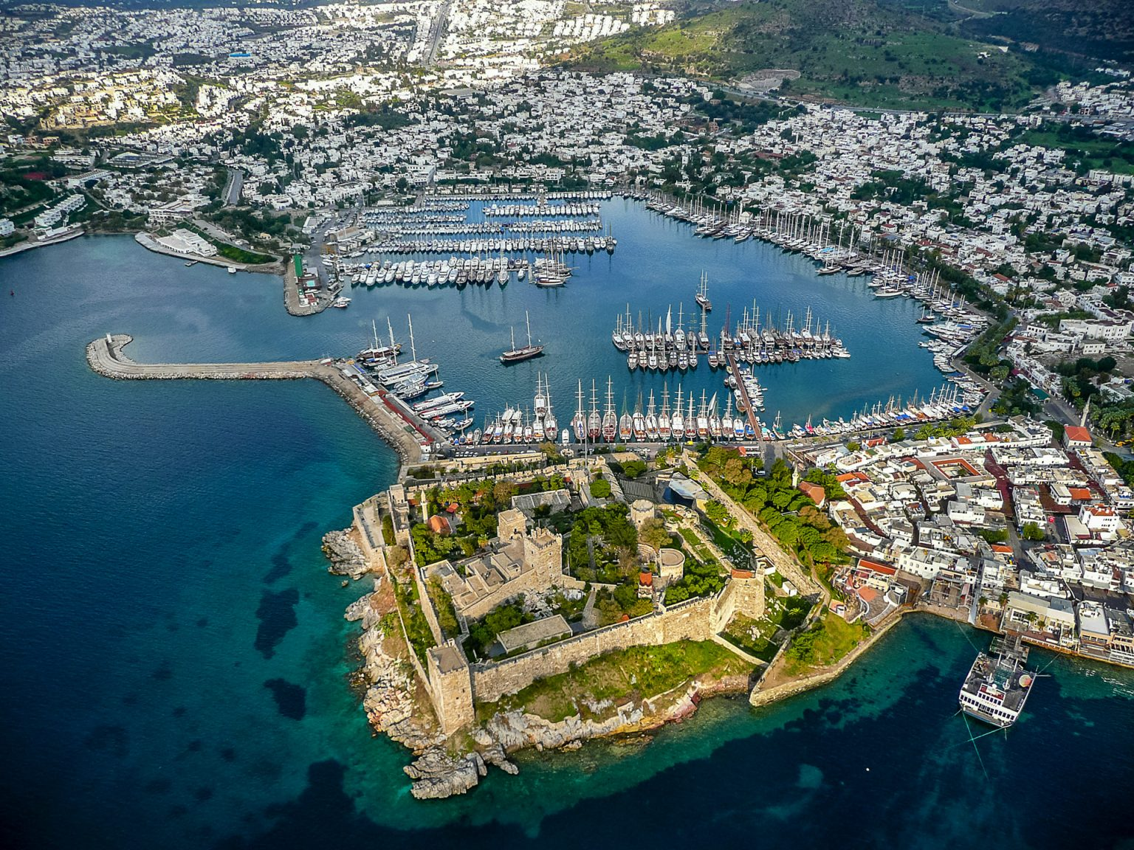
Bodrum

  - Bodrum Castle
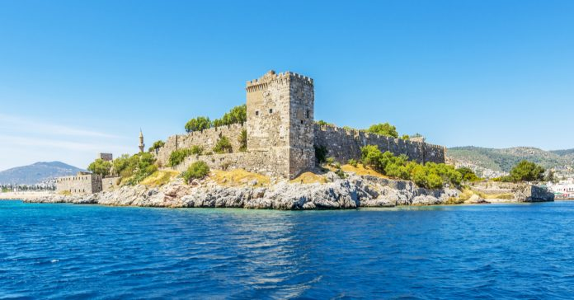
Bodrum Castle was built between 1406 and 1522 and played an important role in the defense of Bodrum. The castle was constructed between two harbors. Having a square plan, Bodrum Castle measures 180 × 185 meters. The French Tower, considered the highest point of the castle, has a height of 47.5 meters.
Bodrum, which carries a sense of romance within everyone, has been one of the most popular settlements of the Mediterranean from the age of myths to the present day. The town, first named “Halicarnassus,” later came to be known as “Bodrum” and was considered one of the leading cities of the region called “Caria.”
Among Bodrum’s most famous landmarks, the Windmills and Bodrum Castle are symbolic structures of the town and among the most visited attractions.
Bodrum Castle is one of Bodrum’s most iconic landmarks, and the Museum of Underwater Archaeology located within the castle makes it one of the most important tourist attractions in Bodrum.
Adress: Çarşı, Kale Cad. 48400 Bodrum/MUĞLA
Phone: 0 252 316 10 95
Visiting Hours: April–October (summer season) 08:30–18:30, November–March (winter season) 08:30–16:30. Closed on Mondays during the winter season.
Distance from the Facility: 19 km

  - Bodrum Ancient Theatre
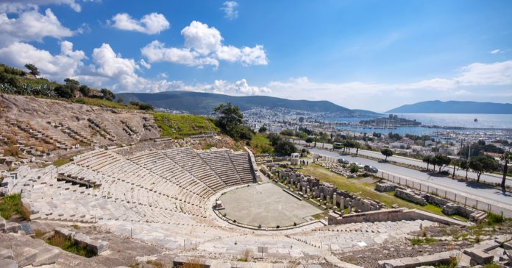
Bodrum Ancient Theatre, located on the southern slope of Göktepe, dates back to the 4th century BC. This important structure, where the history of theater during the Roman Empire era was written, is currently used as a concert venue. Restored in 1990, the theatre was opened to public use with its magnificent view. At the same time, as one of the oldest ancient theatres in Anatolia, it is a historical site that must be visited.
This impressive artistic venue continues to host various artistic activities today. To both enjoy a pleasant event and better experience the historical atmosphere of the region, Bodrum Ancient Theatre should definitely be on your list.
If you wish, you can follow the events held here and plan your visit accordingly. By the way, since the stone seats can become quite hot, we recommend bringing a cushion with you.
Address: Yeniköy, Bodrum, Muğla
Phone: +90 252 316 80 61
Visiting Hours: 09:00–19:00 during the summer season, and 08:00–17:00 during the winter season.
Distance from the Facility: 18 km

  - Myndos Ancient City
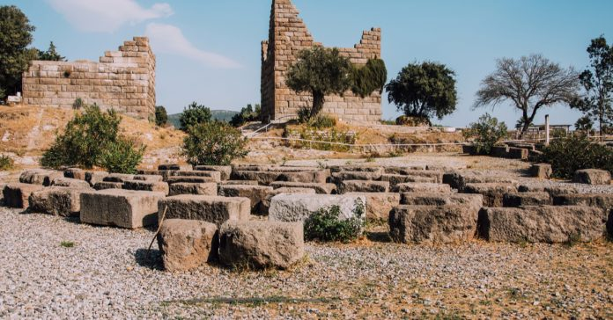
Myndos Ancient City, located in the town of Gümüşlük, is considered one of the sources of ancient inscriptions. It stands at the intersection of Mediterranean and Aegean culture. A large part of the city, which has a rich historical background, remains underwater. It is accepted as one of the eight cities founded by the Lelegians in approximately 640 BC. It is possible to observe the architectural influences of different civilizations, and it is believed that many important ruins, which have not yet been brought to the surface, are still waiting to be discovered underwater within the ancient city.
Myndos Ancient City is conveniently located along the roadside and is easily accessible. Especially during sunrise and sunset, it becomes an important attraction for capturing magnificent photographs. Therefore, Myndos Ancient City is one of the must-visit places during a trip to Bodrum.Adres: Gümüşlük, Bodrum, Muğla
Visiting Hours: Throughout the day
Distance from the Facility: 14 km

  - Myndos Gate
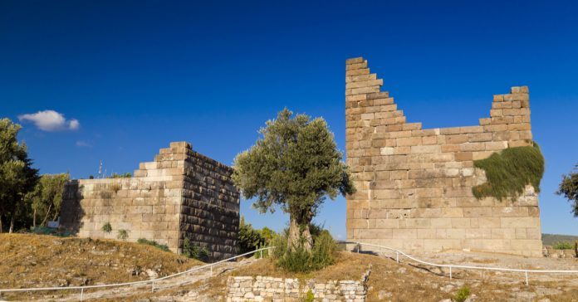
Myndos Gate is believed to have been built around 360 BC. The gate was commissioned by the Carian Satrap Mausolus. Since it was located within the ancient city of Myndos, it became known by the same name. With its impressive appearance, the gate is among Bodrum’s important historical landmarks.
Constructed for defensive purposes, the structure formed a very important protective wall for Halicarnassus and successfully fulfilled its duty. Even Alexander the Great, who sought to capture the city, could not overcome this gate. Another gate built for the protection of the city, the Mylasa Gate, has disappeared over time.
Address: Eskiçeşme, Bodrum, Muğla
Visiting Hours: Throughout the day
Distance from the Facility: 17 km

  - Mausoleum at Halicarnassus
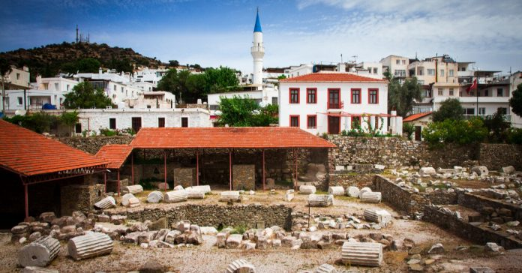
Mausoleum at Halicarnassus is one of Bodrum’s most remarkable historical monuments. It was built in 353 BC by the wife and sister of King Mausolus and is also known as the “Tomb of King Mausolus.” Today, it serves as a museum monument tomb. It is located very close to Bodrum Castle. The mausoleum reflects both Greek and Egyptian architectural styles.
The stones of the Mausoleum at Halicarnassus were used during the construction of Bodrum Castle. It is believed that the monument collapsed as a result of an earthquake after standing for approximately 1,500 years. Some remaining pieces of the mausoleum are currently exhibited at the British Museum.
Although only limited remains of the monument survive today, the Mausoleum at Halicarnassus, which is considered one of the Seven Wonders of the Ancient World, is still among the most important historical sites that must be visited.
Address: Tepecik, Turgut Reis Street No:93, 48440 Bodrum/Muğla
Visiting Hours: Summer season 08:30–18:30, Winter season 08:30–17:30
Distance from the Facility: 17 km

  - Karakaya Village
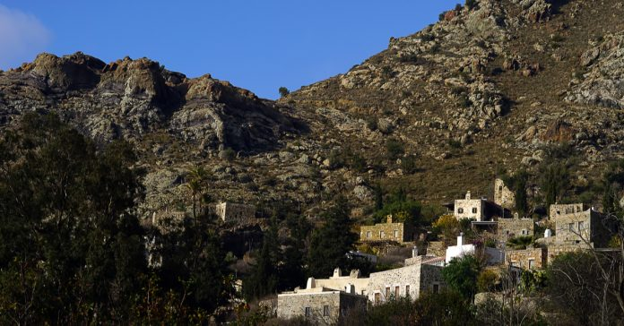
Karakaya Village became one of the safe settlement areas in Bodrum, which was historically vulnerable to attacks coming from the sea due to its location. The village was established after the 14th century and, with its approximately 700-year history, is considered an important treasure of Bodrum’s heritage. Situated at an altitude of 450 meters, the village offers a magnificent view with its similar stone-built houses.
As one of the finest examples of traditional stone architecture in the region, Karakaya Village is among the historical places that must be visited in Bodrum.
Karakaya Village is also famous for its breathtaking view of Gümüşlük Bay. Therefore, when visiting the village, you should definitely take time to enjoy this stunning scenery.
Address: Karakaya Neighborhood, Bodrum, Muğla
Visiting Hours: Throughout the day
Distance from the Facility: 14 km

  - Dibeklihan Culture and Art Village
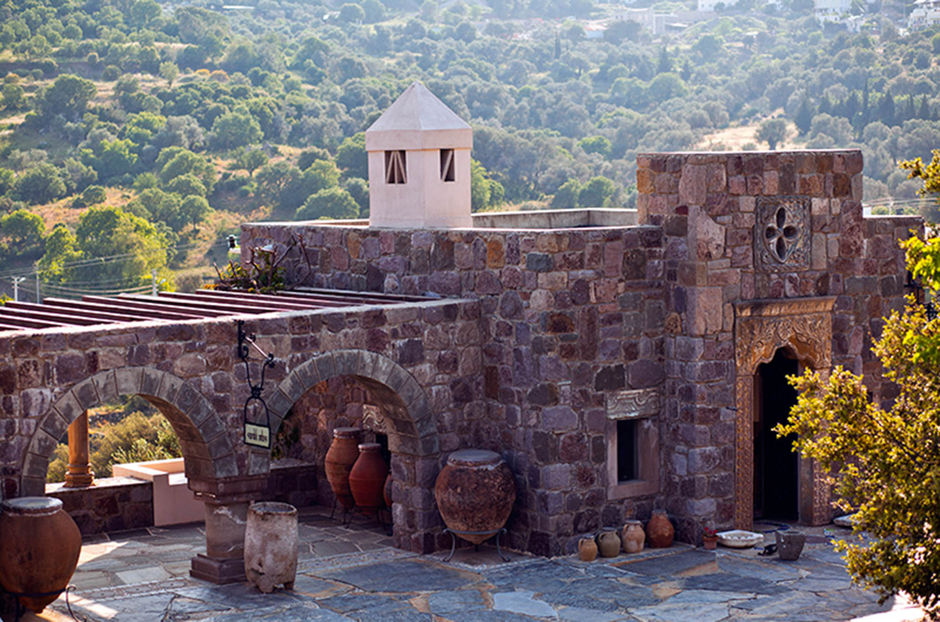
Since 2013, Dibeklihan Culture and Art Village has been serving visitors as a cultural and artistic destination designed to accommodate travelers and meet their needs. Located 13 km from the district center, the Art Village is situated within the borders of Yakaköy, Bodrum. You can reach the village in approximately 20 minutes by private car, or alternatively by using public transportation from the city center.
Due to its extraordinary architecture and location, the venue attracts great admiration from visitors. Within the complex, there are design workshops, handicraft shops, art galleries, restaurants, and cafés.
The venue hosts sculpture and painting exhibitions, film screenings, and dance performances, as well as various artistic and cultural activities such as concerts and fashion shows.
Especially during the summer season, engagement ceremonies, weddings, and similar events are organized at Dibeklihan Culture and Art Village. In the section reserved as an exhibition area, called the “Chest Room,” various items traditionally used by local people in daily life are displayed.
Through the exhibitions, events, and entertaining organizations held at Dibeklihan Culture and Art Village, you can enjoy pleasant moments and experience an unforgettable holiday.
Address: Yakaköy, Bodrum, Muğla
Visiting Hours: Every day of the week except Monday, 10:00–20:00
Distance from the Facility: 9.2 km

  - Windmills
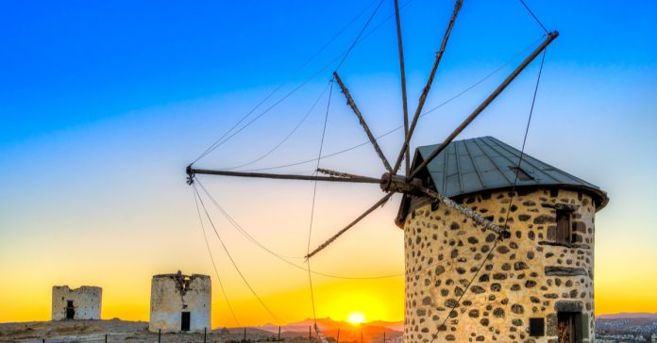
Bodrum Windmills are among the historical symbols of Bodrum due to both their appearance and historical significance. The windmills are believed to have been built in the 18th century, and there are a total of seven of them. Although they were used for their original purpose for many years, only one windmill has survived completely intact to the present day, while the others have suffered damage, especially to their sails.
The windmills are among the places that visitors to Bodrum never leave without seeing. They are also one of the most popular locations for taking memorable Bodrum souvenir photographs.
Address: Gümbet, Bodrum, Muğla
Visiting Hours: Throughout the day
Distance from the Facility: 20 km

  - Ottoman Shipyard
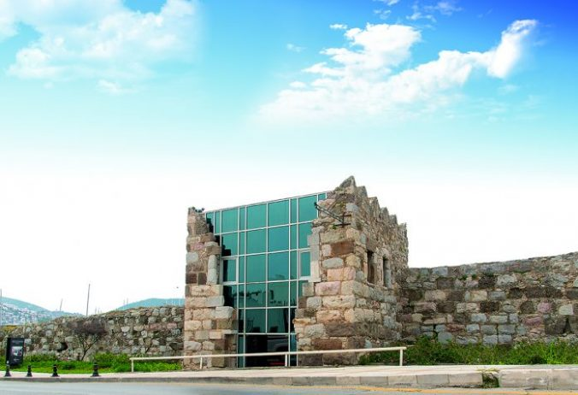
Ottoman Shipyard, whose history dates back to the 1700s, now serves as an art gallery. Behind the structure lies the Ottoman Cemetery. As Bodrum was an important port city, the shipyard played a significant role during its time, and new ships for the Ottoman Navy were built there. Today, the restored Ottoman Shipyard is used for various exhibitions and artistic events.
Within the shipyard, there are graves and tombs belonging to important figures of Ottoman maritime history. At the same time, the artistic activities held there today make the site even more attractive to visitors.
We also recommend not missing the impressive marina view that appears when you climb to the top of the shipyard area.Adres: Eskiçeşme, Neyzen Tevfik Cad. No:5, 48400 Bodrum/Muğla
Visiting Hours: Throughout the day
Distance from the Facility: 17.3 km

  - Apostol Church
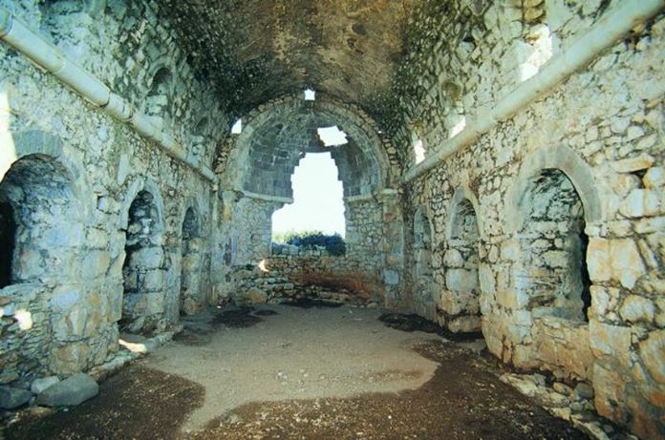
Apostol Church is located on Küçük Tavşan Island and is believed to have been built in the 2nd century BC. It is thought that various additions were made to the church between the 6th and 12th centuries. Because of the church, the island is also referred to as “Saint Apostol Island.”
The church was built with architectural features similar to those of Hagia Sophia, and it is believed that the two structures were constructed during close historical periods. It was designed with a basilica-style plan. The church is under protection by both Italy and Türkiye and is considered a hidden treasure for history enthusiasts.
The restoration works carried out jointly by Italy and Türkiye since 1996 demonstrate how important this church is as a religious and historical site for the world. For this reason, we believe that Apostol Church should definitely be included among the must-see historical places in Bodrum.
The location of the church also offers a magnificent view, so do not miss the opportunity to enjoy the scenery during your visit.

Address: Göltürkbükü, Küçük Tavşan Island, Bodrum, Muğla
Visiting Hours: Throughout the day
Distance from the Facility: 10.8 km

  - Zeki Müren Art Museum
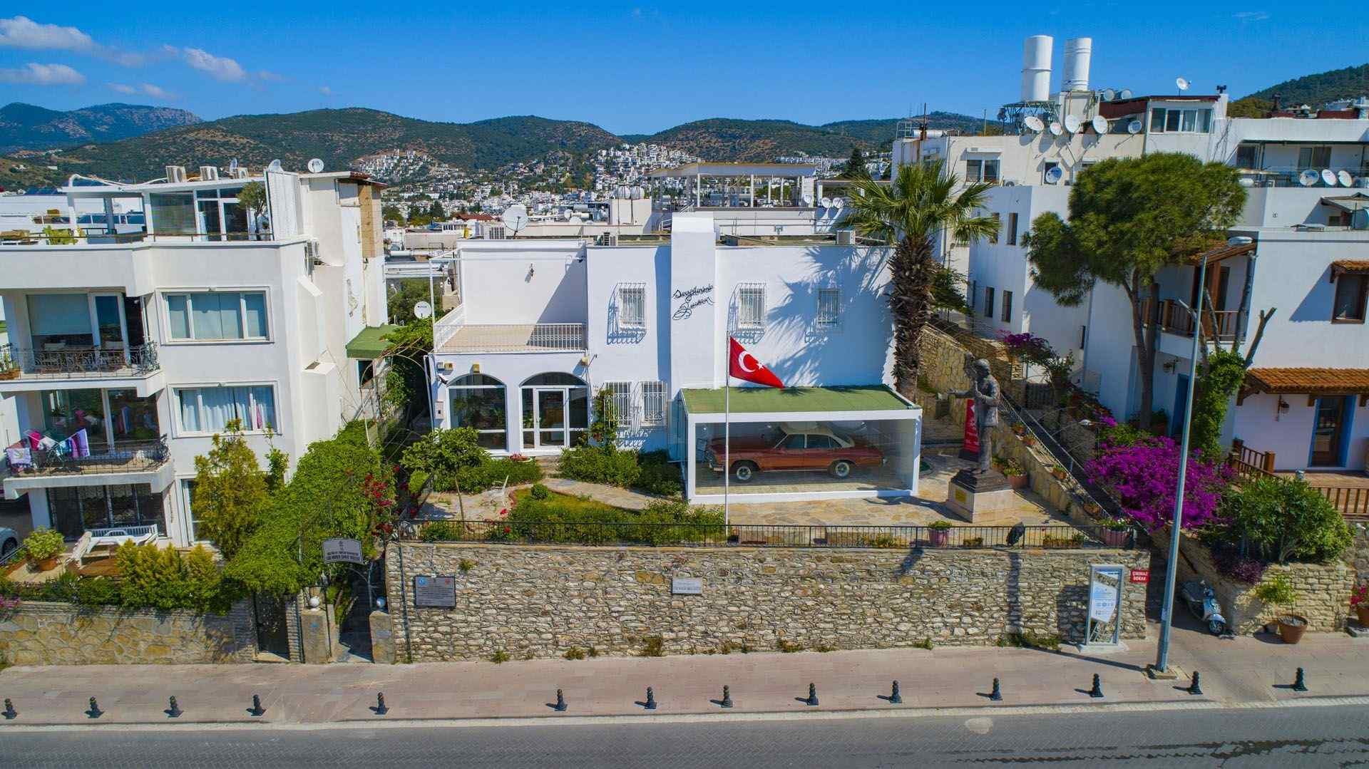
Zeki Müren Arts Museum is a museum dedicated to the memory of Zeki Müren, known as the “Sun of Art,” in Bodrum, where he settled in 1980 and lived until his passing in 1996. The museum offers visitors a wonderful opportunity to discover many different aspects of the artist’s life.
The two-story house where the artist once lived was converted into a museum in 2000 and has since welcomed visitors. Inside the museum, important materials related to the artist can be seen, including various documents, stage costumes, and photographs.
To learn more about one of the most distinguished artists raised in Türkiye, you should definitely add Zeki Müren Arts Museum to your list of must-see places in Bodrum.
Adress: Kumbahçe, Zeki Müren Cad. No:11 48400 Bodrum/MUĞLA
Phone: 0 252 313 19 39
Visiting Hours: Tuesday–Sunday 08:30–17:00
Distance from the Facility: 20 km

Important Guidelines for Visiting Religious, Cultural, and Historical Sites and Museums
Museums are places that preserve and present objects and stories related to culture, art, nature, science, and technology. Learning through authentic objects displayed in museums is often more engaging, exciting, and effective. One of the most important roles of museums is to educate and inform people.
- Pay attention to all warnings and instructions given in museums.
- Follow the directions of museum staff and comply with the visitor rules displayed within the museum.
- At entrances, present identification or a museum card if required, and enter with a valid ticket.
- Remain quiet during museum visits and avoid making noise.
- Do not touch the exhibited artifacts or their display cases/pedestals, and do not write on them. (This warning is especially important for open-air museums and archaeological sites.) Do not damage any objects or artifacts, and do not remove any part of them from the site.
- Pay attention to warnings regarding whether photography is permitted or prohibited.
- Pay attention to warnings regarding the use of flash photography.
- Listen carefully to explanations, and ask guides or museum education specialists (if available) about anything you are curious about.
- Thank the staff members who provide information about the exhibits.
- Do not bring food or beverages into museums.
- Do not damage ancient city sites, enter protected areas, or litter in the surrounding environment.
- Do not have picnics or light fires in natural excursion areas and forests. Do not litter, and pay attention to warning signs.
- During group tours, do not leave the group. If you think you are lost or separated, ask the staff for assistance and go to the information desk.
- Avoid behaviors that may disturb others during visits. Do not establish inappropriate familiarity with adults or children, and do not disturb people.
- The buying and selling of historical artifacts must not be carried out without the necessary permits and documentation. Illegal trade must be avoided.
When visiting places of worship included within faith tourism, such as mosques, churches, synagogues, and similar religious sites, visitors should act respectfully and follow the religious rules and customs of the place being visited.
- Pay attention to the instructions given by staff at the entrances.
- If required, wear appropriate clothing provided at the entrance areas. During mosque visits, shoes should be removed, and women should wear a headscarf.
- People who are praying in worship areas should not be disturbed; visitors should remain quiet and avoid making noise.
- Yiyecek ve içecekle girilmemeli, yerlere çöp atılmamalı gibi hususlara dikkat edilmeli.

Important Considerations for Visits to Natural Areas
- Pay attention to the warnings and instructions given by staff at entrances.
- Do not light fires in wooded or forested areas.
- Do not litter, especially glass items or cigarette butts.
- Never enter restricted areas marked with signs such as “No Entry” or “Swimming Prohibited.”
- Do not damage the habitats of living creatures such as plants and animals living in nature.

Wildlife Protection and Important Considerations During Nature Trips
- While hiking in nature, avoid speaking loudly, listening to loud music, or disturbing the natural silence. This behavior is vital for birds and other living creatures.
- Although feeding wild animals may seem harmless, it disrupts their natural behavior and feeding habits. Animals encountered in nature should not be touched, fed, or harmed.
- Do not leave garbage in natural areas, throw cigarette butts, or light campfires. Follow the principle of “Take back everything you bring.”
- To protect endemic or sensitive species, do not pick flowers, touch animals, or interfere with natural habitats.
- While observing wildlife, keep a safe distance and use non-flash photography. Respect animals’ boundaries to avoid causing them stress.
- If you have pets with you during nature walks, they should always be kept on a leash and under control. Remember that they may pose a threat to wildlife.
- Hunting activities must comply with all applicable laws and regulations. Respect wildlife and natural life.
- To help protect biodiversity, do not purchase products made from endangered species.
You can also access detailed information about Bodrum destinations prepared by the Republic of Türkiye Ministry of Culture and Tourism via:
https://bodrum.goturkiye.com
You can find information about public transportation from the following link:
https://ulasim.muttas.com.tr/
To explore Bodrum by bicycle, learn about cycling routes, and get more detailed information, you can visit:

https://tr.wikiloc.com/rotalari/bisiklet/turkiye/mugla/bodruM
- OUR SAVING MEASURES
Our organization has developed comprehensive saving measures aimed at the efficient use of resources and the reduction of operational costs. These measures not only provide economic benefits but also contribute to reducing environmental impacts and achieving our sustainability goals. Systematic improvement processes are carried out across all departments in the areas of energy, water, material, and time management.
Within the scope of energy conservation, practices such as the transition to LED lighting systems, installation of motion-sensor control mechanisms, climate optimization through central automation systems, and the integration of renewable energy sources have been implemented. To reduce water consumption, low-flow fixtures, greywater recovery systems, and drip irrigation infrastructures have been established.
In material and resource management, digitalization, waste reduction, and reuse principles are prioritized. Digital document management systems have been expanded to reduce paper consumption, while durable and recyclable alternatives are preferred instead of single-use products. In addition, the selection of local and environmentally friendly products within supply chain processes is encouraged, thereby reducing the carbon footprint and contributing to regional development.
All saving measures are supported through employee awareness training programs and performance monitoring systems. In this way, not only technical solutions but also behavioral transformation is achieved, and a culture of saving is promoted throughout the organization.
- OUR GOALS
Our organization acts in line with a future vision that integrates sustainability principles with operational excellence, social responsibility, and environmental awareness. In this context, the goals we have established are structured in alignment with our short-, medium-, and long-term strategic plans. Our objectives represent an approach that considers not only performance indicators, but also stakeholder satisfaction, local development, and ecosystem integrity.
- To reduce energy and water consumption by 2%
- To increase the waste separation rate above 80% within the scope of the Zero Waste target
- To increase the number of sustainability and accessibility training programs provided to all employees
- To increase the local supplier ratio from 87.5% to 90%
- To reduce chemical usage per person by 2%
- To increase annual average guest satisfaction by 1%
- To raise the share of renewable energy resources above 50%
- To increase the number of local plant species monitored within the biodiversity monitoring system by 2%
- To reduce the carbon footprint by 2%
- To lead destination-specific nature conservation and community development projects
Our goals are supported through regular monitoring, measurement, and evaluation mechanisms, and a dynamic management approach is adopted by revising them when necessary. In this way, our sustainability performance is directed not only toward measurable reporting but also toward creating transformative impacts and achieving visible, concrete results.

